Mood board
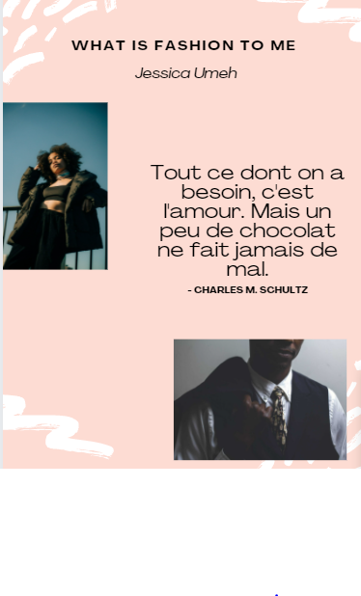

Font = Agrandir Wide
Main idea = What is fashion to me
Colour = FFC0CB

